IoT Project Report

Course Code: EEL005P1X

Employee login status by scanning ID -

Email alert using ThingSpeak & MATLAB

A Project report submitted to:-

Prof. Ankit Dubey sir

**Submitted By:**

Vaibhav Deshmukh (2020PCT0068)

Sankar Behera (2020PCT0067)

Rajat Mittal (2020PCT0066)

M.Tech. Computer Technology (CT)



**INDIAN INSTITUTE OF TECHNOLOGY, JAMMU**

**INDEX**

1. Abstract

2. About

I. Purpose

II. Scope

III. System Requirements

3. Experimental Setup

4. Conclusion

5. Future works

6. References

**About**

**Purpose**:

This project aims to predict hand-written digits (using MNIST training dataset), record them, and send them over to the cloud platform – ThingSpeak.

This project's extended version is to map a unique digit to a person for identification, to trigger a mail to the online meeting's Host.

**System Requirement:**

* Disk: minimum of 30 GB
* Network: Internet Connectivity
* RAM: 4 GB or above

**Software**:

MATLAB – Android Hardware Simulink, Computer Vision ToolBox, Statistics and Machine Learning Toolbox,

Android Studio version 4.0.2

**Hardware**: Android Device, USB cable,

**Procedure**:

Simulink Model:

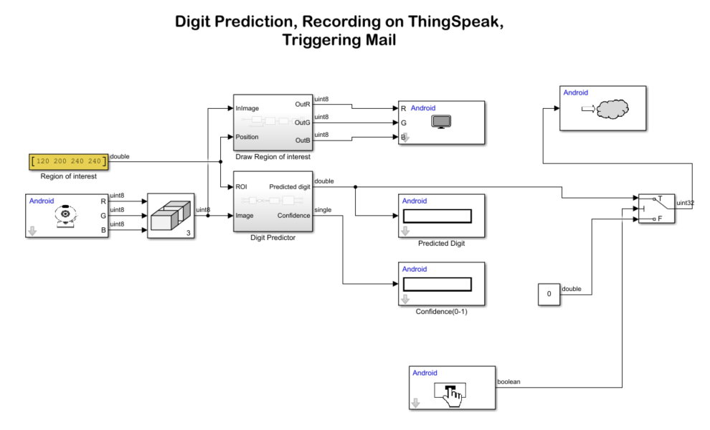

**How to deploy the Simulink model to Android?**

* In the Modelling tab, select Model Settings to open the Configuration Parameters dialog box.
* In the Configuration Parameters dialog box, select Hardware Implementation. Verify that the Hardware board parameter is set to Android Device.
* Go to Hardware board settings > Target hardware resources > Groups and select Device options.
* From the Device list, select your Android device. If your device is not listed, click Refresh.

Note: If your device is not listed even after clicking **Refresh**, ensure that you have enabled the USB debugging option on your device. To enable USB debugging, enter **androidhwsetup** in the MATLAB® Command Window and follow the onscreen instructions.

* On the **Hardware** tab, click the **Build**, **Deploy**, & **Start** button. This action builds, downloads, and runs the model as a standalone application on the Android device. The application continues to run even if the device is disconnected from the computer.
* The application opens the device camera. You will see a region of interest (ROI) marked as a red box inside the camera frame. Only the image inside the ROI is used for prediction.
* Draw a digit on a whiteboard.
* Capture the digit in the camera frame of your device. Ensure that the digit is enclosed inside the ROI. On capturing the digit, the algorithm processes the image as explained here.
  + The Camera block accepts the digit captured using the camera of your Android device. The image obtained is of size 640x480. The image is passed to the Concatenate block to perform multidimensional concatenation of R, G, and B pixels. The Draw Region of Interest and Digit Predictor subsystems accept the image and ROI as inputs.
  + The Draw Region of Interest subsystem draws the ROI starting from (120,240) to (200,240) pixels. To draw the ROI, this image is converted to single and then converted back to RGB.
  + In the Digit Predictor subsystem, the RGB2bin block converts the image into its binary equivalent and then extracts the ROI from the input image. The block complements the image and resizes the image to 28-by-28 pixels. The 28-by-28 image is then passed to the Extract Image Features block to extract the Histogram of Oriented Gradients (HOG) features. The extracted features are passed to the Predict Digit block. The block loads the compact trained model, originalMNIST.mat, to predict the digit from the extracted features. For information on how the originalMNIST.mat is trained, see Digit Classification Using HOG Features on MNIST Database. The predicted output is then given to the Data Display, Predicted Digit, and Confidence(0-1) blocks to display the predicted digit along with the probability of the prediction.
* Creation of Thingspeak channel, "GettingEmpID," to sense numeric digits recognized by Android application deployed via MATLAB Simulink.

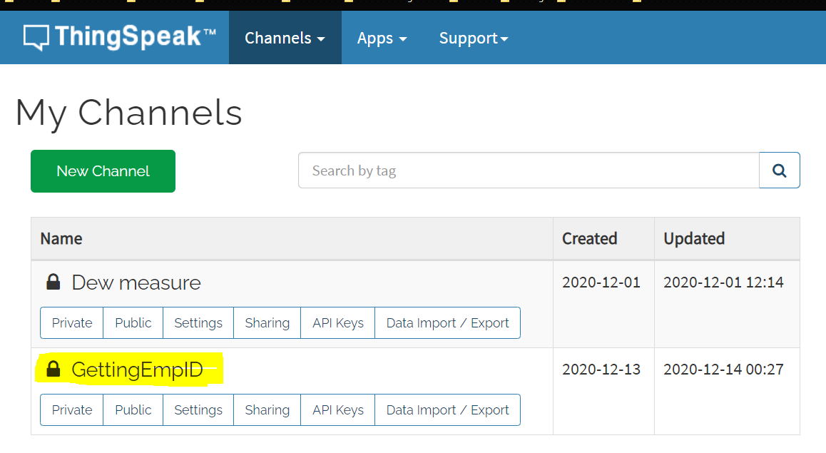

* Visualization of recorded digits using graph widget on ThingSpeak.

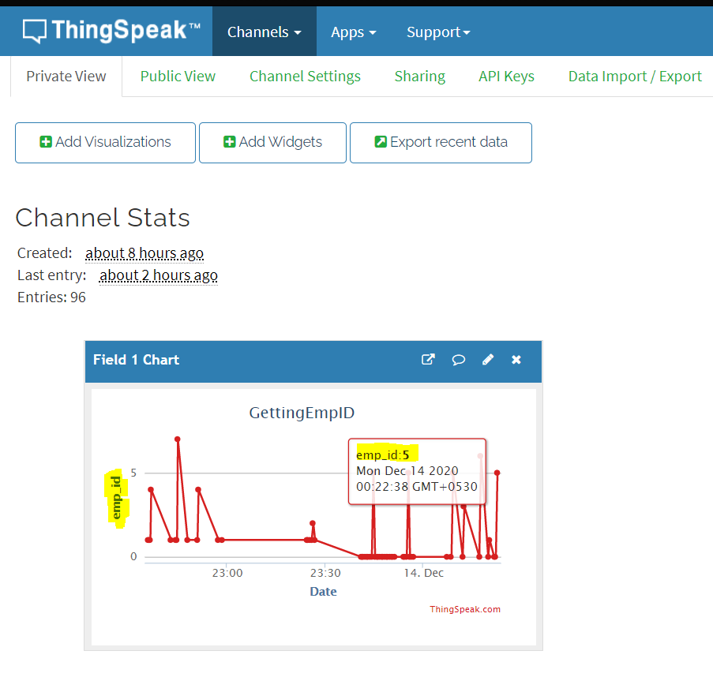

* Code to map a recognized digit to a person and triggering mail to the Host that the particular person has joined the meeting.

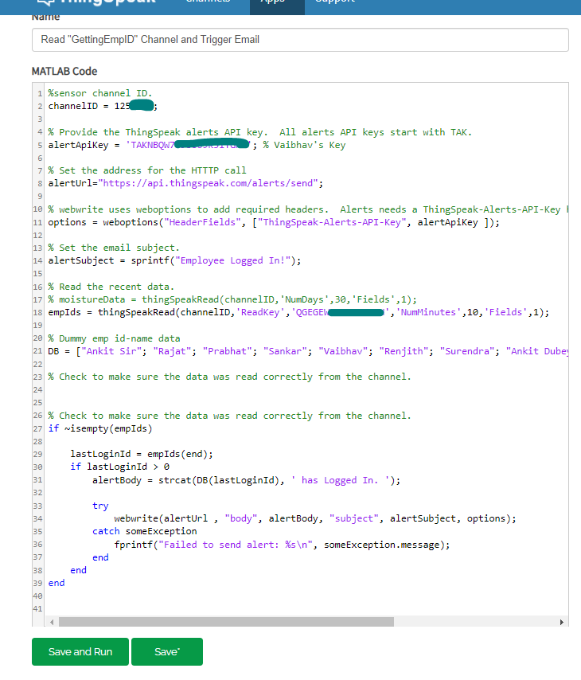

* A “React” service to trigger the app *Read "GettingEmpID" Channel and Trigger Email* when the recognized digit is greater than 0.

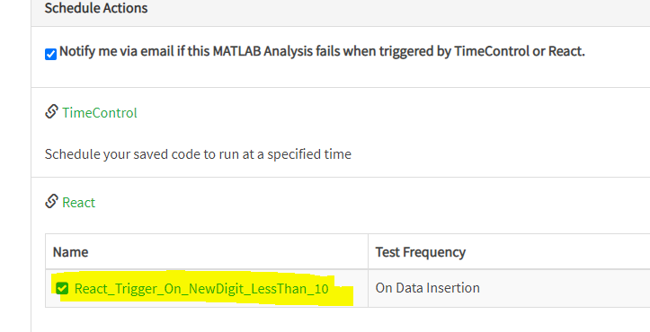

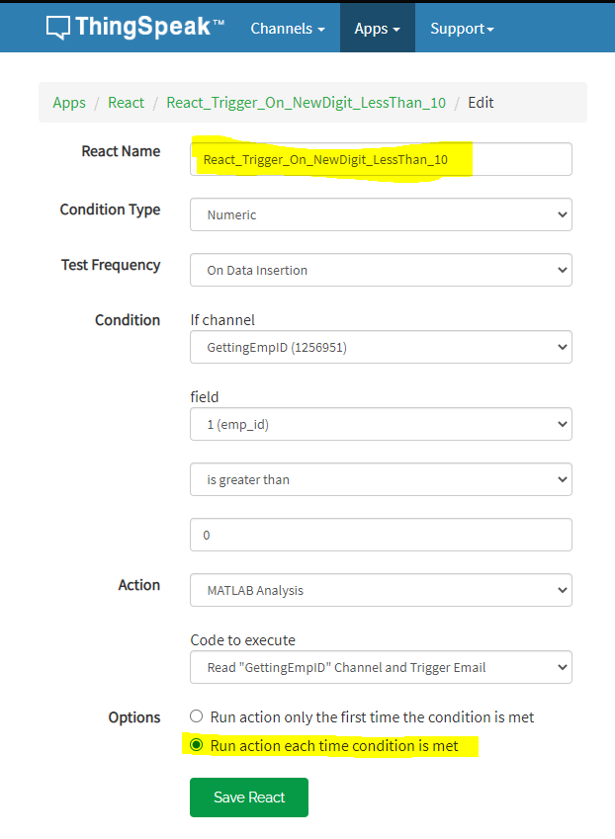

* Screenshot of email received for alert using ThingSpeak cloud.

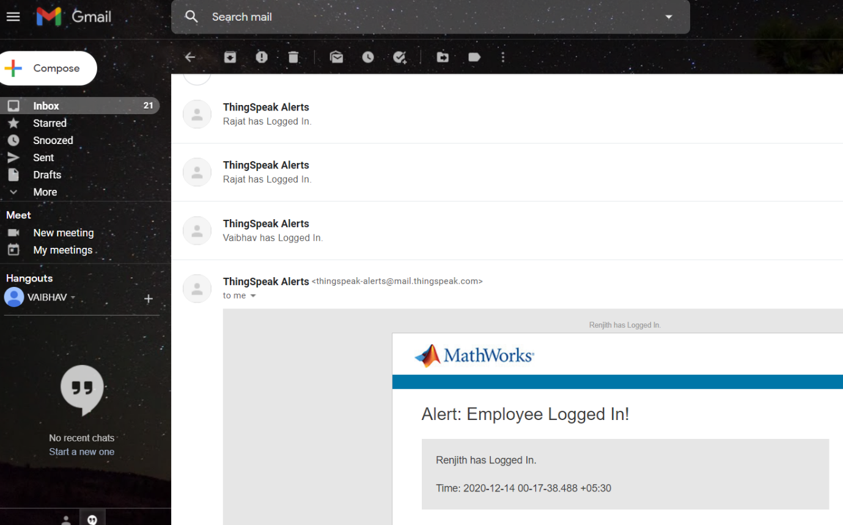

**Conclusion**:

The app is using android service things ThingSpeak and its services to trigger a mail to the Host by using Handwritten digits scanning.

**Future Works:**

We can extend it to track student login status in online classrooms (e.g. ipearl platform, IIT Jammu) and we can calculate particular student’s logged in time.

**References:**

<https://in.mathworks.com/help/supportpkg/android/ref/recognize-handwritten-digits-using-mnist-on-android.html>

<https://in.mathworks.com/help/simulink/index.html>

<https://www.tutorialspoint.com/matlab/index.htm>

THANK YOU!